**TEST EVIDENCE – SECURITY-4 -- Authenticate using JWT token**

1. First hit the username password api:

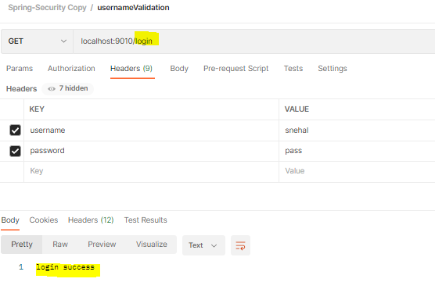

We will get otp in the response header:

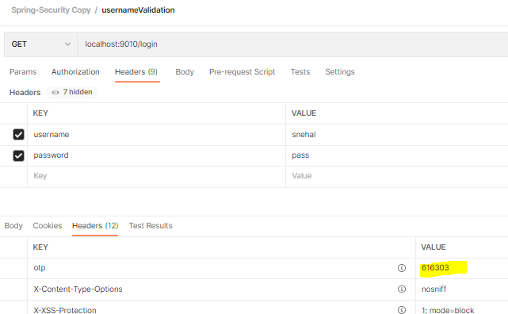

1. Next hit the otp api

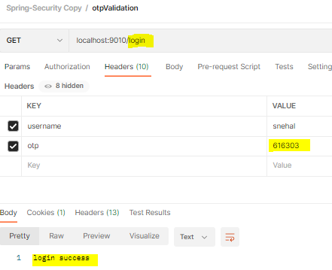

We will get authorization token in the response header:

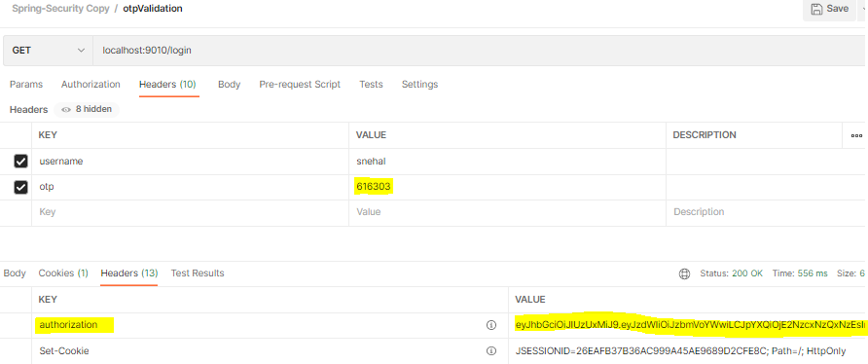

1. Next access the /user api with authorization token:

